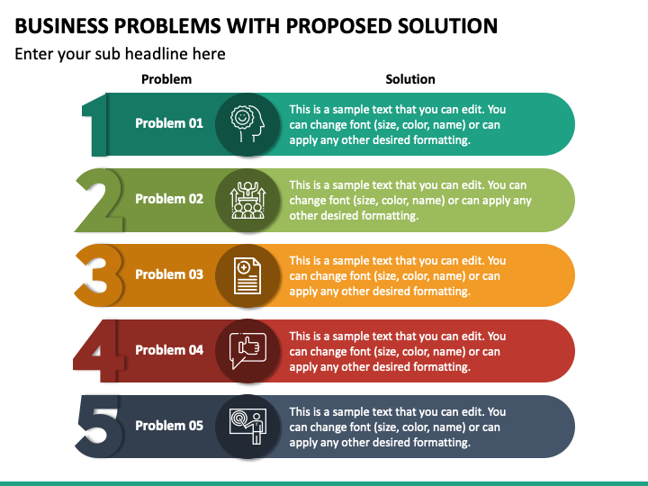

## Installing data limiting resources

Data availability

## Placing cooler in front of system or fix non thermal conducting material

**Emerging methods for early detection of forest fires**

**Proposed Solution**

Availability

Sensibility

Power consumption

System

heating

Using low cost and high efficiency devices

Increasing resolution of Camera

Using rechargeable battery

And self-charging programs